**# 4. Write a Program to implement Informed search technique: A* Algorithm**

**def** aStarAlgo(start_node, stop_node):

        open_set **=** set(start_node)

        closed_set **=** set()

        g **=** {} #store distance from starting node

        parents **=** {}# parents contains an adjacency map of all nodes

        #ditance of starting node from itself is zero

        g[start_node] **=** 0

        #start_node is root node i.e it has no parent nodes

        #so start_node is set to its own parent node

        parents[start_node] **=** start_node

**while** len(open_set) > 0:

            n **=** None

            #node with lowest f() is found

**for** v **in** open_set:

**if** n **==** None **or** g[v] **+** heuristic(v) < g[n] **+** heuristic(n):

                    n **=** v

**if** n **==** stop_node **or** Graph_nodes[n] **==** None:

**pass**

**else**:

**for** (m, weight) **in** get_neighbors(n):

                    #nodes 'm' not in first and last set are added to first

                    #n is set its parent

**if** m **not** **in** open_set **and** m **not** **in** closed_set:

                        open_set.add(m)

                        parents[m] **=** n

                        g[m] **=** g[n] **+** weight

                    #for each node m,compare its distance from start i.e g(m) to the

                    #from start through n node

**else**:

**if** g[m] > g[n] **+** weight:

                            #update g(m)

                            g[m] **=** g[n] **+** weight

                            #change parent of m to n

                            parents[m] **=** n

                            #if m in closed set,remove and add to open

**if** m **in** closed_set:

                                closed_set.remove(m)

                                open_set.add(m)

**if** n **==** None:

                print('Path does not exist!')

**return** None

            # if the current node is the stop_node

            # then we begin reconstructin the path from it to the start_node

**if** n **==** stop_node:

                path **=** []

**while** parents[n] !**=** n:

                    path.append(n)

                    n **=** parents[n]

                path.append(start_node)

                path.reverse()

                print('Path found: {}'.format(path))

**return** path

            # remove n from the open_list, and add it to closed_list

            # because all of his neighbors were inspected

            open_set.remove(n)

            closed_set.add(n)

        print('Path does not exist!')

**return** None

#define fuction to return neighbor and its distance

#from the passed node

**def** get_neighbors(v):

**if** v **in** Graph_nodes:

**return** Graph_nodes[v]

**else**:

**return** None

#for simplicity we ll consider heuristic distances given

#and this function returns heuristic distance for all nodes

**def** heuristic(n):

        H_dist **=** {

            'A': 11,

            'B': 6,

            'C': 99,

            'D': 1,

            'E': 7,

            'G': 0,

        }

**return** H_dist[n]

#Describe your graph here

Graph_nodes **=** {

    'A': [('B', 2), ('E', 3)],

    'B': [('C', 1),('G', 9)],

    'C': None,

    'E': [('D', 6)],

    'D': [('G', 1)],

}

aStarAlgo('A', 'G')

**Input:**

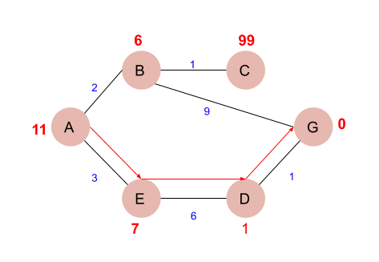

**Output:**

Path Found: [ 'A','E','D','G']